Gourmet Growth Case Study Documentation & Guide

1. Please use the data to build out a dashboard that can be used for all companies with the

same data structures.

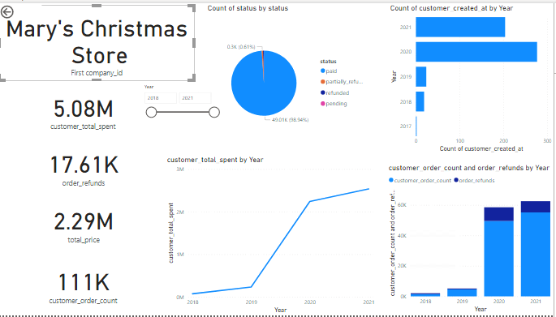

See Power BI dashboard. To standardize the data structures and visualizations for all companies, a filter for one company will apply to all visualizations. A filter is required for one company for all visuals. Also, there is an option to filter by year to dial down to more detail.

By visual:

1. Summary of total sales by all customers

2. Summary of total refunds, total price (net of refunds) and total order count

3. Pie chart displaying percentage of order statuses

4. Line graph displaying trend of total customer sales over the periods of time

5. Bar graph displaying newly onboarded customers over the periods of time

6. Stack chart displaying proportion of sales and refunds over the periods of time

2. Once the dashboard is complete, please put together a brief summary of your findings

and observations on these three companies. Please be succinct in your response.

Jim’s Gym Supplies:

* Best year for sales was 2020, with a sharp -98.5367% decline just one year after in 2021
* Sharp 166% growth from 2018 to 2019 in revenue and customer onboarding
* Best year for newly onboarded customers was 2019 and 2019 was the second best performing year in regards to sales
* Most refunds in 2019

John’s Boardgame Shop:

* Second best performing year in sales count (2020) is the top year in new customer onboarding. Top year in sales revenue
* Top performing year 2021 in sales count is the second best year in new customer onboarding. Second best year in sales revenue
* Sharp 502.827% growth from 2019 to 2020
* 9.04188% decrease 2020 to 2021
* Second highest status is partially refunded, what is the nature of a partial refund? Does this impact earnings?
* Most refunds in 2020

Mary’s Christmas Store:

* Most customers onboarded and most refunds in 2020
* Sharp 859.073% growth from 2019 to 2020
* Top performing year in customer count correlates with sharp growth (from 2019 to 2020)
* Top performing year in revenue and sales count was 2021
* 98% of orders were paid for

Instructions for using Power BI Dashboard:

Must select a single company to use dashboard, can select company on filter panel:

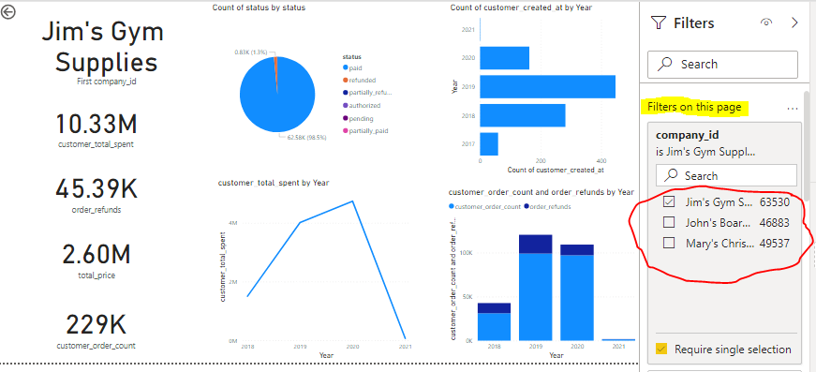

See from all years or filter by year:

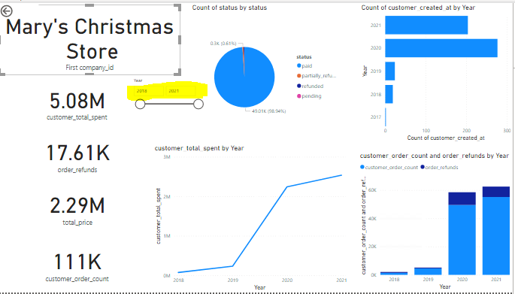

Appendix

CREATE TABLE gg(

"order_id" int,

"company_id" TEXT,

"created_at" date,

"status" text,

"total_price" float,

"order_refunds" float,

"customer_id" int,

"customer_order_count" int,

"customer_total_spent" float,

"customer_created_at" date)

